**FAAN TRAINING CENTER**

**ARFFS Training Unit**

**Undercarriages**

INTRODUCTION

The design characteristics and construction of aircraft undercarriages are as wide and varied as the aircraft themselves. In some cases they are subjected to enormous loads and operational stresses.

These loads on occasions have proved too much resulting in component failure and the subsequent involvement of the aircraft in an accident. Firefighters must recognize the hazards associated with undercarriages in order to work safely and effectively around them.

AIM

The aim of this note is to explain the design and construction characteristics of aircraft undercarriages, the hazards they present and the actions to be employed at incidents in which undercarriages are involved.

OBJECTIVES

After careful study of this training note and after participation in technical and practical sessions of instruction participants will be able to:

* Describe the general design features of aircraft undercarriages
* Explain the circumstances in which incidents involving undercarriages occur
* State the actions to be employed at undercarriage incidents
* Recognise the hazards associated with aircraft undercarriages

**BACKGROUND**

The design, method of operation, size and number of undercarriages will be determined by,

* The overall size of the aircraft
* The maximum take-off weight of the aircraft
* The landing characteristics of the aircraft
* The type of aircraft

They can range from fixed skids or wheel assemblies on light aircraft or helicopters to huge fully retractable multi-wheeled bogies on large passenger or freight aircraft. **Whatever the size and design the purposes of undercarriages remain the same. They:**

* **Absorb shock on landing**
* **Support the weight of the aircraft and provides stability when it is parked, maneuvering on the ground or taking off**
* **Provide steering for the aircraft**
* **Provide breaking systems for the aircraft**

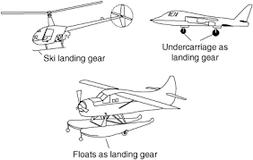

**CONSTRUCTION**

In general terms an aircraft undercarriage is made up of several component groups that facilitate its function.

**Oleo leg** – This is normally a vertical telescopic strut that absorbs shock in a similar way to the suspension on a car.

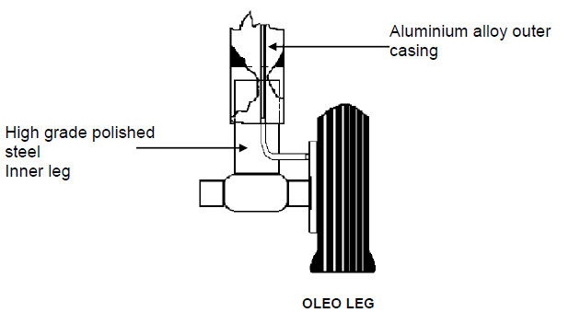

The damping is provided by a combination of gas and oil. The gas is normally Nitrogen and the oil is a synthetic hydraulic fluid. Pressures can be as high as 200 bar.

**Brakes**

The complexity of the brakes will be proportionate to the size of the aircraft. On light aircraft they will be very similar to the disc brakes found on a car. Large aircraft will have what is referred to as a brake stack which consists of a number of rotating disks separated by static discs of friction material when the brakes are applied the rotating discs and static friction plates are squeezed together. This action causes resistance to the turning of the wheels so slowing the aircraft. Vast amounts of heat can be generated during this process. Traditionally brake disks were made from high quality steel but these are gradually being superseded with carbon units. These units offer a considerable weight saving and greater resistance to thermal shock. Also, unlike metal, carbon offers greater braking efficiency at high temperatures.

**Wheels**

Various alloys are used to construct aircraft wheels. Tyres can be made from a combination of synthetic and natural rubber. They are normally inflated with Nitrogen to a pressure of 12-13 bar. In order to overcome dangerous pressure build up when the wheels are hot, fusible plugs are fitted. These are small bolts that have a small hole drilled through the centre. This hole is filled with a low melting point metal (normally 150oC – 250oC). If the wheels get excessively hot the low melting point metal melts and allows Nitrogen to escape thus venting excessive pressure. The escaping Nitrogen is directed towards the brakes offering some cooling effect. The effect of the continuous landing and taking off can lead to the buildup of rubber dust which has an ignition temperature of around 250oC – 350oC.

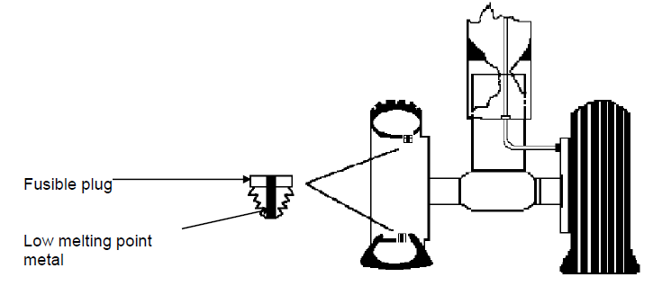

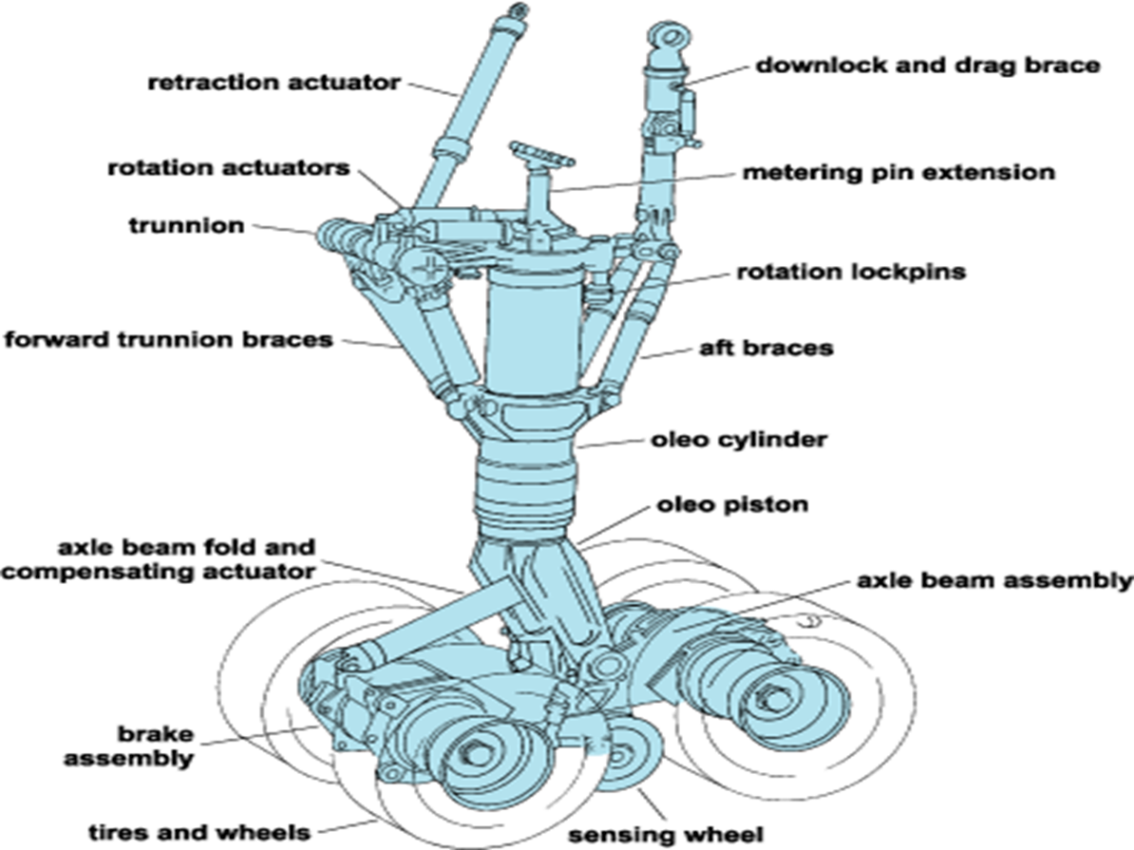

**Retraction System**

This may be an extremely complex system of rigid and flexible pipework and hydraulic actuators. Their purpose is to fold the undercarriage assembly away into the underside of the wing or fuselage. Hydraulic systems can operate at pressures as high as 200 bar.

Steering Mechanisms (Nose-wheel only)

This uses a hydraulic system similar to the retraction gear on main undercarriages to provide a steering capability to the nose wheel.

**UNDERCARRIAGE PROBLEMS**

Smaller undercarriages such as fixed single wheel assemblies on light aircraft and skids on small helicopters rarely cause major problems. The main causes of problems are the larger retractable units. These can cause problems in the following ways:

* **Generation of heat during excessive braking (i.e. rejected take-off)** – Temperatures up to 1000oC may be generated when a pilot drives brakes to the limit to bring a fast moving, fully laden aircraft to a halt on the remaining available runway. Another cause of heat generation may be prolonged taxiing. To overcome this some aircraft have cooling fans incorporated into the undercarriage to improve airflow over the assembly.

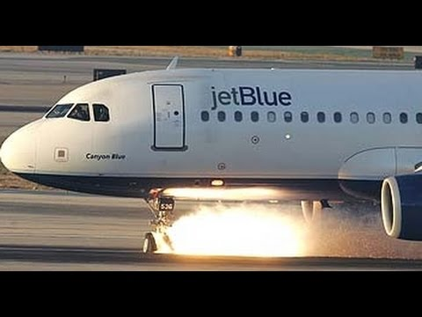

* **Burst/Deflated tyres** – This can be caused by heavy landings or excessive braking leading to fusible plugs releasing excessive pressure. Ultimately this can result in the aircraft travelling down the runway on wheel rims, which in turn can severely damage undercarriage systems leading to possible collapse.

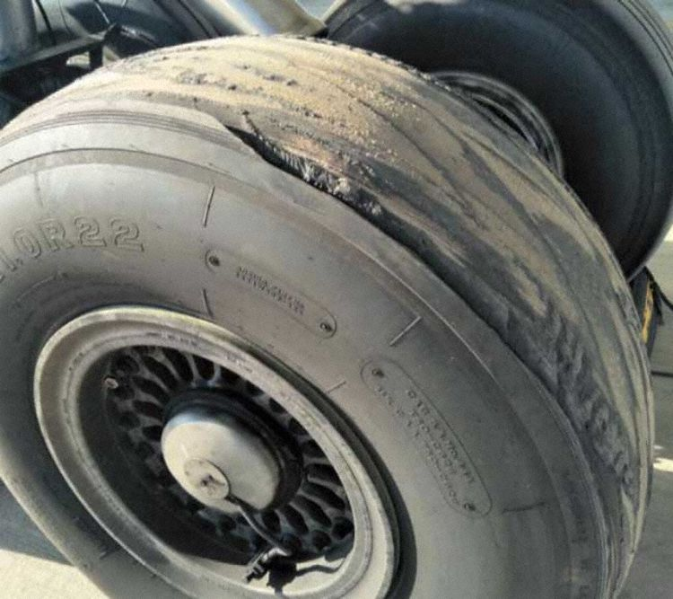

* **Deployment Problems** – There are numerous deployment problems that will result in an aircraft having difficulty performing a normal landing, examples are; failure to deploy the nose-wheel, one or more main undercarriages failing to deploy or only partially deploying, undercarriages deploying but not locking in position correctly.

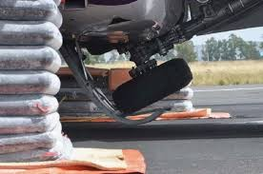 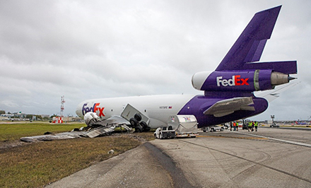

**ACTIONS TO BE EMPLOYED**

The officer in charge will determine the actions to be employed at an incident involving an undercarriage assembly.

Although there cannot be any rigid rules, the following actions should be considered.

* **Position appliances so that the monitors can be used to protect the fuselage** if necessary but taking into consideration the possible collapse of the undercarriage and subsequent movement of the aircraft.
* **Deploy hoses and secondary media** – If the undercarriage is overheated but not on fire it may be desirable to leave it to cool naturally. This overcomes the possibility of spot cooling causing failure or pressurized components. In some cases cooling may be required to prevent heat from conducting away from the undercarriage assembly and affecting otherwise uninvolved areas of the aircraft.
* **Avoid danger areas** – The minimum number of personnel should be working around the undercarriage. Firefighters should avoid positioning themselves under the main plane or alongside the wheels in the hub disintegration area.
* If firefighting or the application of water for cooling is required this should be done from the best position to ensure uniform cooling, thus reducing the risk of explosions due to thermal shock. Normally this will involve firefighters working from an upwind position and applying media to encompass the whole assembly. In some cases, teams of firefighters approaching from fore and aft may produce the best results. NOTE: The design characteristics of the particular aircraft may make access to the undercarriage very difficult.
* If the tyres are burning the fire may prove to be very difficult to fully extinguish. The dual application of water/foam spray and a secondary agent may prove to be most successful.
* As soon as it is safe to do so locking pins should be inserted to prevent collapse. (The assistance of a ground engineer or member of the aircraft crew may be of benefit). The aircraft should also be chocked to prevent movement if brakes have failed.
* If an evacuation is taking place the RFFS may have to assist aircraft cabin crew in moving passengers away from the aircraft to a place of safety.
* If the undercarriage has damaged fuel tanks, any spillages should be covered with aspirated foam and action taken to prevent the flow of fuel until the aircraft can be de-fueled.

**HAZARDS**

The following are the main hazards that may be present at incidents involving aircraft undercarriages.

**Highly Pressurized Components** – These can fail sometime after an aircraft has come to a standstill. There is a danger of debris being ejected with explosive force particularly in the hub disintegration area. To avoid injury personnel should only approach undercarriages if it is vital to do so. Numbers should be kept to a minimum and full protective clothing should be worn with helmet visors down.

**Instability of the Aircraft** – Avoid areas under the aircraft, insert locking pins and chock the aircraft ASAP.

**Hydraulic Fluid** – Cracks or damage to hydraulic pipework can lead to hydraulic fluid being released under extreme pressure. This presents the risk of a jet flame and also **fluid** penetrating exposed skin. Full protective clothing should be correctly worn at all times.

**Toxic Smoke/Carbon Fibers** – Due to the materials that may be burning or the type of extinguishing media used there may be vast amounts of toxic smoke given off by a burning undercarriage. If this is the case, breathing apparatus should be worn.

N.B. Experience has shown that steam produced by applying water-based extinguishing Media to a hot undercarriage assembly may ‘lift’ carbon deposits from landing gear and give the appearance of smoke. If there is any doubt, treat as Smoke.

**Involvement of Combustible Metals** – Magnesium alloy is often used in the construction of wheels. If it is involved in fire there is a danger of molten metal showering the area (see training note “Aircraft Construction”.)

**Close Proximity of Aircraft Engines** – The layout of many aircraft is such that the undercarriage is located close to aircraft engines. This could expose firefighters to the hazards presented by engine intakes and exhausts or propellers. Action should be taken to get engines closed down before approaching undercarriages.

**SUMMARY**

The design characteristics, size and layout of aircraft undercarriages will vary over a wide range.

It is important that firefighters recognize the hazards associated with undercarriages and the actions required to safely and effectively deal with such incidents.